Les Couleurs
Color | Male Singular | Female Singular | Male Plural | Female Plural
 | Rouge
 | Jaune
 | Bleu
 | Vert
 | Orange
 | Violet
 | Rose
 | Marron
 | Gris
 | Noir
 | Blanc
Quelle est la couleur?
La couleur est ______.
Qu’est-ce que c’est?
C’est une_____________.
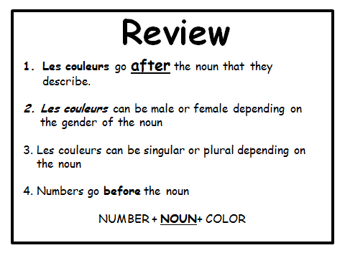
Traduire
- Five Red Apples - _______________________________________
- Thirty-five Green Girls ___________________________________
- One Pink Nose - ________________________________________
- Ten Blue Gentlemen- ____________________________________
- Red Lips- _____________________________________________
- Twenty black Days- _____________________________________
- Purple Boy- ___________________________________________
- Brown Hand- __________________________________________
- Two White Eyes- ______________________________________
- Three Pink Houses- ____________________________________
- A Black Female Cat- ____________________________________
- A Yellow rose- ________________________________________
- Ninty-nine Blue Pens- ___________________________________
- Seventy- four Green Pencils - _____________________________
- One pink pencil- ______________________________________
- Black hair- __________________________________________
- Fifty-two orange fingers- _______________________________
- Eighty-three grey books- _______________________________
- A purple pencil - _____________________________________
- A Grey apple- _______________________________________

